Latest tech shop

Sheeven Jean

*Computer Science Department, Middle Tennessee State University   
1301 East Main St. , Murfreesboro, TN , USA*

smj5m@mtmail.mtsu.edu

CSCI 4560

***Abstract*— The goal of this project is to create an online shop where users can purchase the latest, mostly out of stock everywhere, technological advancements. From the latest IPhone, IPad, Mac, Samsung, the untraceable PS5s and Xbox series. The user can register or log in if they’re already registered. I plan to have pictures of the products and a search function that the users can filter by brand or category. The user cam then add items to their cart and checkout. I plan on adding an admin version as well, where I can manage inventory, add/remove items, make new admins etc.**

Introduction

The inspiration for this project was quite random and out of the blue. I had just fallen out of my group- by my own fault, yes- and was now scrambling to come up with something by myself. At the same time, on a personal level my phone was broken and I was scouring the internet for a replacement and the Iphone 14 was absolutely impossible to get a hold of. And that’s when it hit me! A shop for the most demanded and sold-out tech items of today.

My inspiration for the database and overall design of what I want the shop to look like comes from the most popular technology sales stores we have today, most notably best buy (which is where I ended up getting my phone from). I also took some inspiration from YouTube and other fellow amateur developers.

II. Project Overview

Most examples of ecommerce schemas I’ve found online are either this simple or even more complex, so I want to start with that as barebones and built onto it. I also have a pretty good idea what might be needed based on my extensive background of online shopping. At the base if everything, we should have inventory. So, a products table is priority. It should contain it’s ID as a primary key, the product category, brand, type, and price. Following that is a cart so the customers can put products in consisting of its ID as primary key as well, along with information on the product similar to the products table. Speaking of customers, we also need a user table to be able to start a shopping session, with their ID/username, email and password.

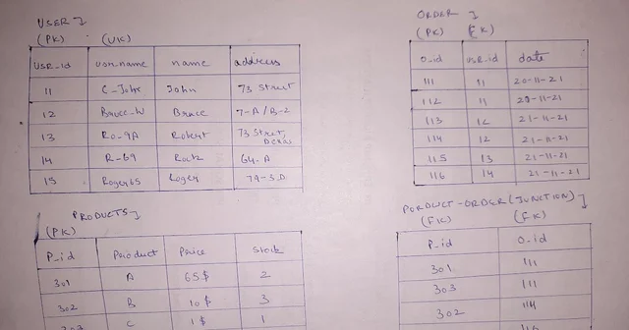

So far, this is what I’m picturing the tables looking like. Obviously will need more details such as payment information but I’m not really sure how these will look like yet.

For the front page, I believe I need PHP ad HTML to connect to the database. Since I can’t really pay and register a domain for this project (for financial and security reasons) the page will be accessible through phpMyAdmin, a very useful tool for building databases online. It’ll need to be accessed through xamp though and might need some ports changed but I will detail those out in a readme.